RAINFALL, FLOODING &
ENVIRONMENTAL RISK IN NIGERIA

Using Data Analytics to Explore Rainfall Patterns and Reported Flood Impacts

PREPARED BY:
Adeniran David Oluwadamilare

PROJECT SCOPE
Rainfall Analysis: 1901-2025
Rainfall-Flood Comparison: 1985-2022
Tools: Microsoft Excel - Microsoft Power BI

Nigeria | 2026

Executive Summary

This project examines historical rainfall patterns in Nigeria and investigates how annual rainfall relates to recorded flood events and reported flooded area. Monthly precipitation data covering 1901-2025 were analyzed using Microsoft Excel, while recorded flood-event data covering 1985-2022 were combined with annual rainfall data for the comparative analysis. Microsoft Power BI was then used to develop a dashboard presenting the major findings.
The rainfall analysis shows substantial year-to-year variability rather than a strong, consistent linear increase. Annual precipitation ranged from 887.81mm in 1983 to 1,451.20mm in 1957. For the common comparison period of 1985-2022, annual rainfall showed a positive relationship with both recorded flood events (r = 0.341) and reported flooded area (r = 0.439).
The results indicate that higher annual rainfall tended to be associated with greater reported flood impacts, particularly reported flooded area. However, rainfall alone does not explain most of the variation. Flooding is influenced by several other factors, including rainfall intensity and location, drainage, land use, urban development, topography, river condition and infrastructure. The project therefore demonstrates the value of combining climate and disaster data to support evidence-based understanding of environmental risk in Nigeria.

TABLE OF CONTENTS
Executive Summary 2
1. Introduction 4
2. Research Question 4
3. Objectives 4
4. Data Sources 4
5. Methodology 5
6. Findings 5
6.1 Rainfall Trend and Variability 5
6.2 Flood Occurrence 5
6.3 Reported Flooded Area 6
6.4 Relationship Between Rainfall and Flooding 6
7. Key Insights 6
8. Limitations 6
9. Conclusion 7
10. Recommendations 7
11. Tools Used 7
12. Power BI Dashboard 8
13. Selected Verified Project Statistics 8
14. References 9
15. Appendix: Key Calculations 9

Introduction

Flooding is one of the major environmental risks affecting communities in Nigeria, with impacts on lives, livelihoods, infrastructure, agriculture and economic activity. Rainfall is an important factor in flooding, but flood impacts can also be influenced by drainage systems, land use, urban development, river conditions, topography and infrastructure.
This project examines historical rainfall patterns in Nigeria and investigates their relationship with recorded flood events and reported flooded areas. Historical monthly rainfall data from 1901 to 2025 were analyzed to understand long-term rainfall variability, while recorded flood-event data from 1985 to 2022 were used to examine flood occurrence and reported impacts.
The analysis combines Microsoft Excel and Microsoft Power BI to transform, analyze and visualize the data. The aim is not to claim that rainfall alone causes flooding, but to identify patterns and assess how strongly annual rainfall is associated with recorded flood impacts.

Research Question

How does annual rainfall relate to recorded flood events and reported flooded areas in Nigeria between 1985 and 2022?

Objectives

- Analyze historical rainfall patterns in Nigeria using monthly precipitation data from 1901 to 2025.
- Measure annual rainfall variability and identify unusually wet and dry years.
- Examine recorded flood-event occurrence and reported flooded area between 1985 and 2022.
- Assess the relationship between annual rainfall and recorded flood impacts.
- Present the results in a Power BI dashboard for clear communication and decision-making.

4. Data Sources

The project combines historical precipitation data with recorded flood-event data. The rainfall dataset contains 1,500 monthly observations from January 1901 through December 2025. The flood archive used for the analysis contains 68 recorded Nigeria events covering 1985–2022.
- Historical rainfall/precipitation data: monthly precipitation covering 1901–2025.
- Flood-event archive: recorded Nigeria flood events covering 1985–2022.
- Power BI: final dashboard created from the cleaned and analyzed datasets.

5. Methodology

The rainfall dataset was converted from a wide monthly format into a clean date-and-precipitation structure in Microsoft Excel. Monthly values were aggregated into annual precipitation totals. Quality checks confirmed 1,500 monthly observations, with no blank values and no negative precipitation values.
The flood archive was filtered for Nigeria, and the year of each recorded event was extracted. Annual flood-event counts and archive-reported flooded areas were calculated. The rainfall and flood datasets were aligned for the common period of 1985–2022.
Correlation analysis was used to examine the relationship between annual rainfall and recorded flood events, and between annual rainfall and reported flooded area. Microsoft Power BI was then used to create the final dashboard.

6. Findings

6.1 Rainfall Trend and Variability

Annual precipitation fluctuated considerably between 1901 and 2025, with a slight upward linear trend. However, the linear trend had an R² of 0.0338, meaning that it explained only about 3.38% of the variation in annual precipitation.
Annual rainfall ranged from 887.81 mm in 1983 to 1,451.20 mm in 1957, giving a range of 563.39 mm. The five wettest years were 1957 (1,451.20 mm), 1954 (1,415.31 mm), 1909 (1,392.56 mm), 1955 (1,366.54 mm), and 1963 (1,359.25 mm).
The five driest years were 1983 (887.81 mm), 1914 (969.83 mm), 1973 (993.47 mm), 1987 (1,025.86 mm), and 1977 (1,030.77 mm). Decade-level analysis showed no simple continuous increase or decrease. The lowest complete-decade average occurred in 1981–1990 at approximately 1,079.54 mm.

6.2 Flood Occurrence

Between 1985 and 2022, the flood archive contained 68 recorded events, averaging approximately 1.79 recorded events per year. The highest annual number of recorded events occurred in 2003, with 9 events.
Nine years had no recorded major flood events in the archive: 1986, 1987, 1989, 1993, 1996, 2008, 2014, 2016 and 2022.

6.3 Reported Flooded Area

Reported flooded area varied substantially between 1985 and 2022. The average reported flooded area was approximately 172,136.45 km² per year. The largest annual archive-reported total occurred in 2019, at 1,471,789.48 km².
The 2019 value represents the area reported in the flood-event archive and should not be interpreted as an area that was necessarily underwater simultaneously.

6.4 Relationship Between Rainfall and Flooding

For 1985–2022, annual rainfall showed a positive relationship with recorded flood events (r = 0.341) and a stronger positive relationship with reported flooded area (r = 0.439).
Rainfall explained approximately 11.6% of the variation in recorded flood-event counts and approximately 19.3% of the variation in reported flooded area. This indicates that higher annual rainfall tended to be associated with greater reported flood impacts, particularly reported flooded area, but rainfall alone does not explain most of the variation.

7. Key Insights

- Rainfall varies considerably across Nigeria's historical record, with no strong simple linear trend.
- The wettest year in the full rainfall record was 1957, while 1983 was the driest.
- Recorded flood events varied considerably, with 2003 having the highest number of recorded events.
- 2019 had the highest annual rainfall in the 1985–2022 overlap period (1,296.65 mm) and the largest archive-reported flooded area (1,471,789.48 km²).
- Rainfall showed a positive association with reported flooded area, but explained only about 19.3% of its variation.
- Flooding is a multi-factor environmental risk rather than a phenomenon explained by rainfall alone.

Limitations

- The flood archive represents recorded major events and does not capture every flood occurrence.
- The rainfall dataset is spatially aggregated and does not represent rainfall at every individual location in Nigeria.
- Annual rainfall totals can hide short-duration rainfall intensity and location-specific extreme events.
- Correlation indicates association and does not establish causation.
- Other important flood drivers, including drainage, land use, urbanization, topography, river conditions and infrastructure, were not modeled directly.
- The direct rainfall–flood comparison covers 1985–2022 because that is the common period of the two datasets.

9. Conclusion

This project examined historical rainfall patterns in Nigeria and their relationship with reported flooding. The analysis shows substantial rainfall variability over time and no strong consistent linear increase in annual precipitation. Between 1985 and 2022, rainfall was positively associated with both recorded flood events and reported flooded area, but the relatively low explanatory power shows that rainfall alone cannot account for most flood variation.
The findings reinforce the importance of viewing flooding as a multi-dimensional environmental risk. Better flood-risk assessment should combine rainfall information with drainage, land use, urban development, river conditions, infrastructure and other environmental indicators.

10. Recommendations

- Combine rainfall data with local rainfall intensity, river-level and drainage information for more detailed flood-risk analysis.
- Use location-specific data to identify communities and regions with higher exposure to flooding.
- Develop dashboards that integrate climate, environmental and infrastructure indicators for decision-making.
- Support early-warning systems with accessible and timely data.
- Expand future analysis to include land-use change, urbanization, topography and river conditions.

Tools Used

- Microsoft Excel : Data cleaning, transformation, aggregation and statistical analysis.
- Microsoft Power BI : Dashboard development, visualization and presentation.
- DAX : Power BI calculations and measures.

12. Power BI Dashboard

The final dashboard presents the main rainfall and flooding indicators, including average annual rainfall, average flood events per year, highest annual rainfall, highest reported flood area, total reported flood events, rainfall trends, recorded flood-event trends, reported flooded area by year, and the rainfall-versus-reported-flooded-area relationship.
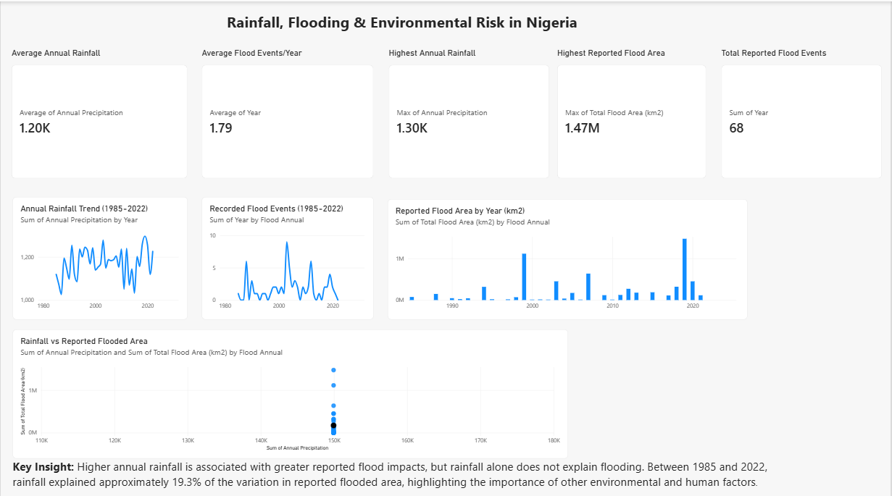
Figure 1: Power BI dashboard showing rainfall, recorded flood events and reported flooded area in Nigeria, 1985-2022.

13.Selected Verified Project Statistics

Indicator | Verified result
Rainfall period | 1901-2025
Rainfall observations | 1,500 monthly observations
Rainfall mean, 1901-2025 | 1,199.53 mm/year
Wettest year | 1957 - 1,451.20 mm
Driest year | 1983 - 887.81 mm
Flood comparison period | 1985-2022
Recorded flood events | 68
Average flood events/year | 1.79
Highest annual flood-event count | 2003 - 9 events
Average reported flooded area/year | 172,136.45 km²
Largest reported flooded area | 2019 - 1,471,789.48 km²
Rainfall vs flood events | r = 0.341; R² ≈ 11.6%
Rainfall vs reported flooded area | r = 0.439; R² ≈ 19.3%
Rainfall trend R², 1901-2025 | 0.0338

14. References

- Dartmouth Flood Observatory. Nigeria Flood Event. https://floodobservatory.colorado.edu/wiki/Nigeria
- National Emergency Management Agency (NEMA). Flood Alert 2024. https://nema.gov.ng/flood-alert-2024/
- Nigeria Flood Early Warning System. Nigeria Flood Early Warning System. https://nigeriafews.com.ng/
- Nigeria Hydrological Services Agency (NIHSA). Flood Forecast Dashboard. https://nihsa.gov.ng/Flood-forecast-dashboard
- World Bank. Climate Change Knowledge Portal (CCKP): Download Data. https://climateknowledgeportal.worldbank.org/download-data

Appendix: Key Calculations

- Rainfall Analysis
- Annual Precipitation: Monthly precipitation values were summed for each year from 1901-2025.
- Average annual rainfall: AVERAGE was used to calculate the mean precipitation.
- Maximum and minimum rainfall: MAX and MIN functions were used to identify the wettest and driest years.
- Rainfall trend: A linear trendline was applied to the annual series, producing an R² of 0.0338.
- Flood Analysis
- Flood events per year: Flood records were grouped by flood year using COUNTIF.
- Total reported flooded area: Flooded area were aggregated by year using SUMIF.
- The flood archive covered 1985-2022 for the comparative analysis.
- Rainfall-Flood Relationship
The relationship between rainfall and flooding was assessed using correlation and R²:
- Rainfall vs. Flood events: r = 0.341; R² ~ 11.6%
- Rainfall vs. Reported flooded area: r = 0.439; R² ~ 19.3%
These association measures indicate association, not causation.
- Power BI
The final dashboard was developed using:
- Annual rainfall trend
- Recorded flood events
- Reported flood area
- Rainfall vs. Reported flooded area
- Key performance indicators (KPIs)
- Key insight text

